NAME:- SANIKA MILIND YADAV.
ROLL NO:-DW245
PROJECT TITLE: NETFLIX TITLES DATA ANALYSIS

PROBLEM STATEMENT:-
" I am analyzing the Netflix Titles dataset to understand what kind of content is available on Netflix and what factors influence content distribution. This dataset is taken from Kaggle and contains over 6000+ rows and multiple columns such as type, country, release year, rating, and duration. Each row represents a movie or TV show available on Netflix. "

Import Libraries:-
import pandas as pd
import numpy as np
import matplotlib.pyplot as plt
import seaborn as sns

from sklearn.model_selection import train_test_split
from sklearn.preprocessing import LabelEncoder
from sklearn.tree import DecisionTreeClassifier
from sklearn.metrics import accuracy_score

Upload Dataset:-
from google.colab import files
uploaded = files.upload()
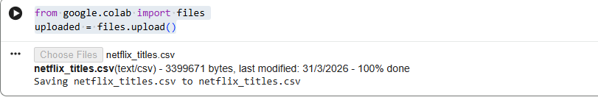

Load Dataset:-
df = pd.read_csv('netflix_titles.csv')

print(df.head())
print(df.shape)
print(df.dtypes)
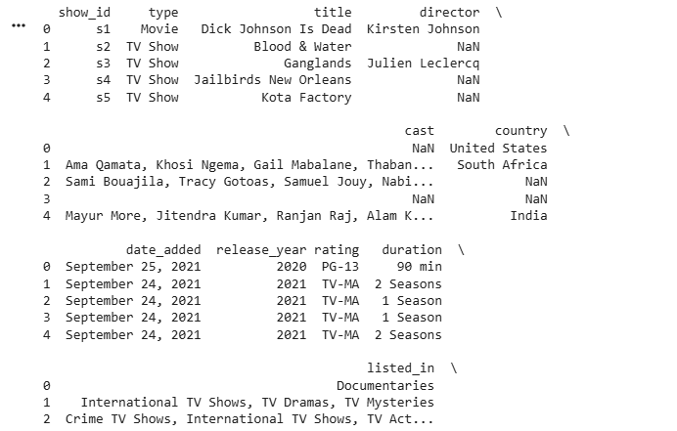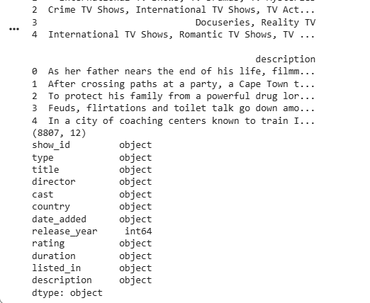
Data Cleaning Check missing values:-
print(df.isnull().sum())
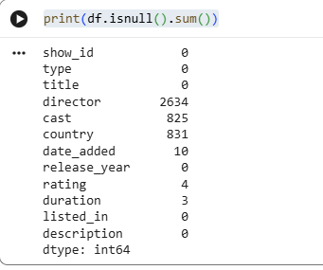

Fill missing categorical values:-
for col in df.select_dtypes(include='object').columns:
df[col].fillna('Unknown', inplace=True)
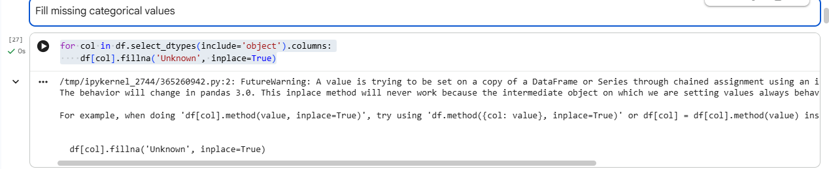

Fill numeric missing values:-
for col in df.select_dtypes(include=np.number).columns:
df[col].fillna(df[col].median(), inplace=True)
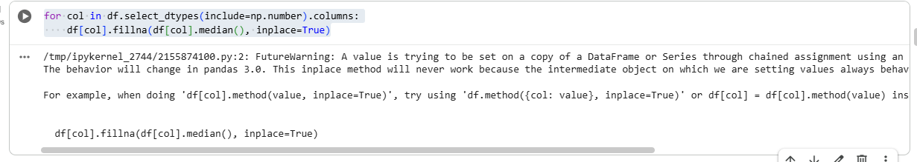

Remove duplicates:-
print("Duplicates before:", df.duplicated().sum())
df.drop_duplicates(inplace=True)
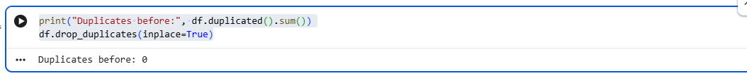

🔹 Statistics Convert duration to numeric:-
df['duration_num'] = df['duration'].str.extract('(\d+)').astype(float)
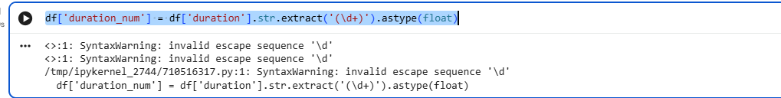

Calculate stats:-
for col in ['release_year', 'duration_num']:
print(f"\nStats for {col}:")
print("Mean:", df[col].mean())
print("Median:", df[col].median())
print("Mode:", df[col].mode()[0])
print("Std:", df[col].std())
print("Variance:", df[col].var())
print("Range:", df[col].max() - df[col].min())
print("Mid-range:", (df[col].max() + df[col].min()) / 2)

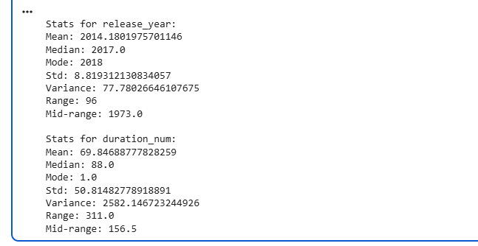

🔹 Visualization Histogram
plt.figure()
plt.hist(df['release_year'])
plt.title('Distribution of Release Year')
plt.xlabel('Year')
plt.ylabel('Frequency')
plt.show()

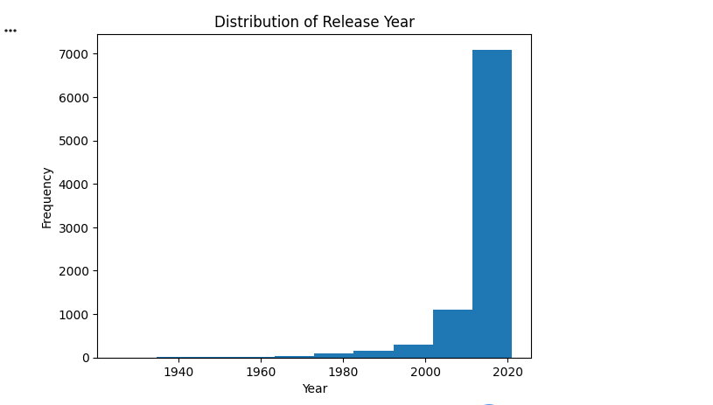

Bar Chart:-

plt.figure()
sns.countplot(x='type', data=df)
plt.title('Movies vs TV Shows')
plt.xlabel('Type')
plt.ylabel('Count')
plt.show()

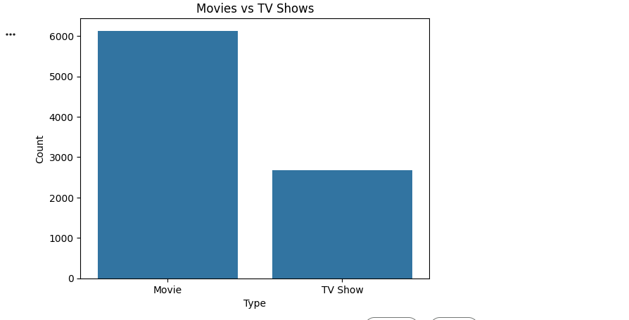

Boxplot:-

plt.figure()
sns.boxplot(x=df['duration_num'])
plt.title('Content Duration Spread')
plt.xlabel('Duration')
plt.show()

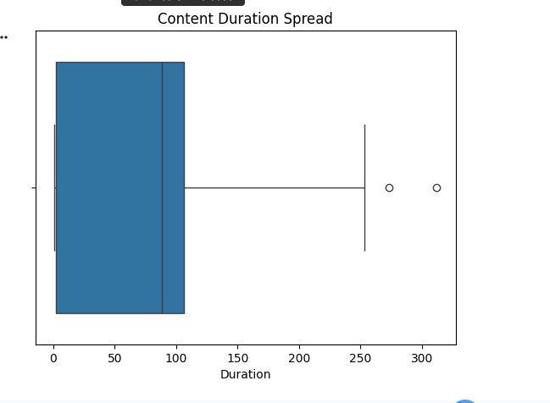

Heatmap:-
plt.figure(figsize=(8,5))
sns.heatmap(df.select_dtypes(include=np.number).corr(), annot=True)
plt.title('Correlation Heatmap')
plt.show()

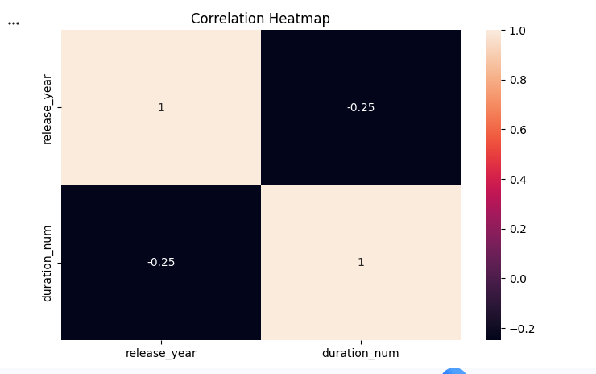

🔹 Encoding
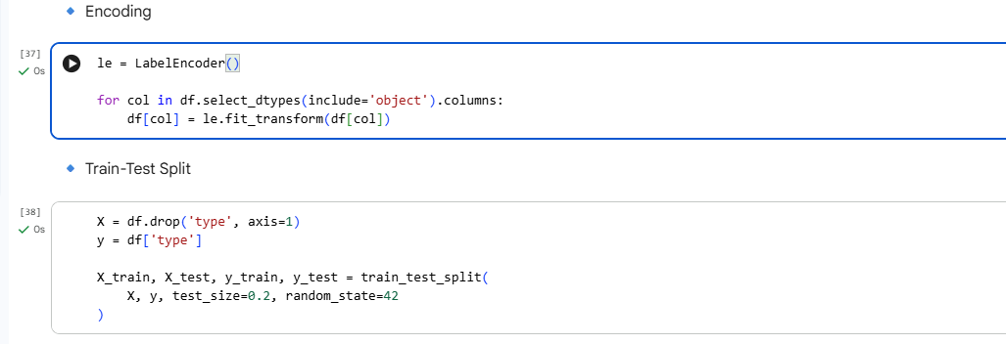

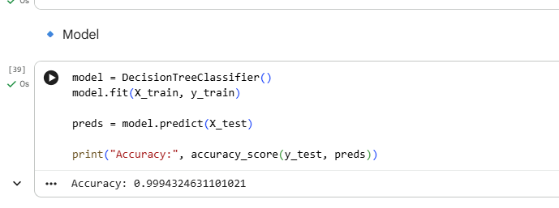

Insights:-

Finding 1: Most content on Netflix is movies rather than TV shows.
Finding 2: The histogram shows a sharp increase in content after 2010. Finding 3: The boxplot shows some extreme duration outliers.

Recommendations:-
1. Focus on producing more recent content as it dominates the platform.
2. Balance between movies and TV shows for better audience engagement.

